**Dokumentasi**

**Home Page :**

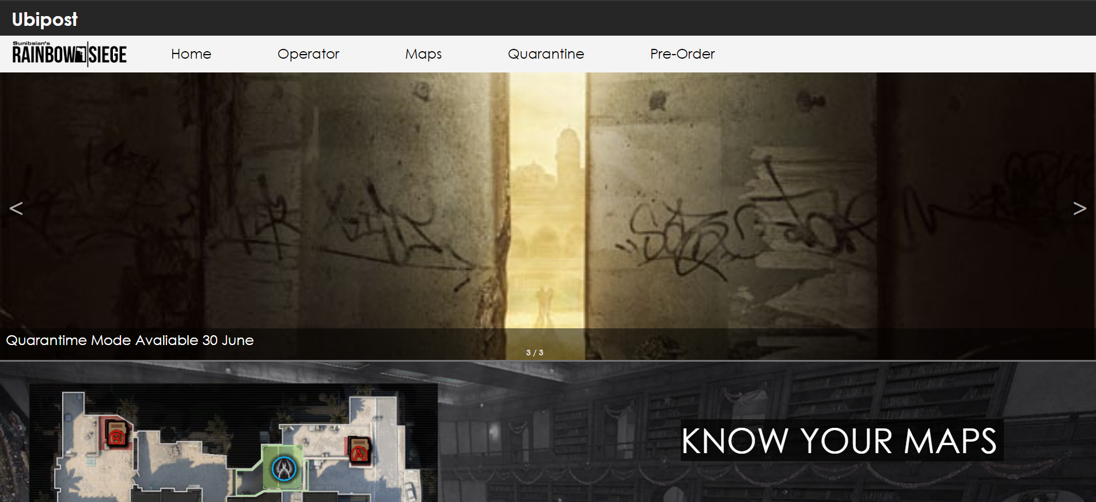

Tampilan homepage pada saat 800px

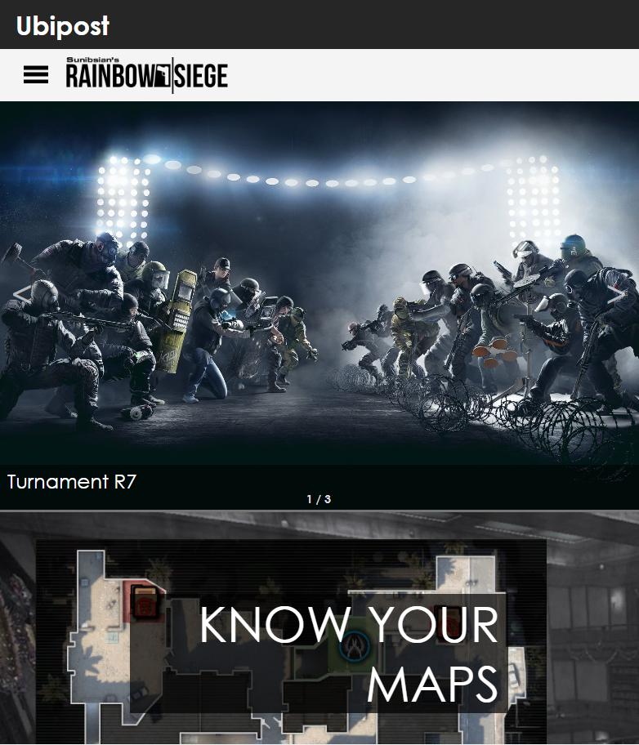

Tampilan Side-Nav pada saat 800px :

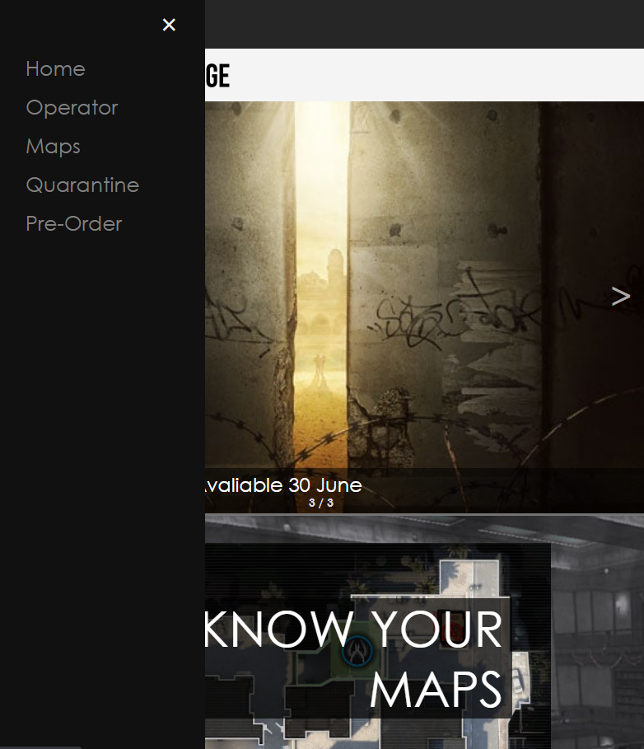

**Operator Page :**

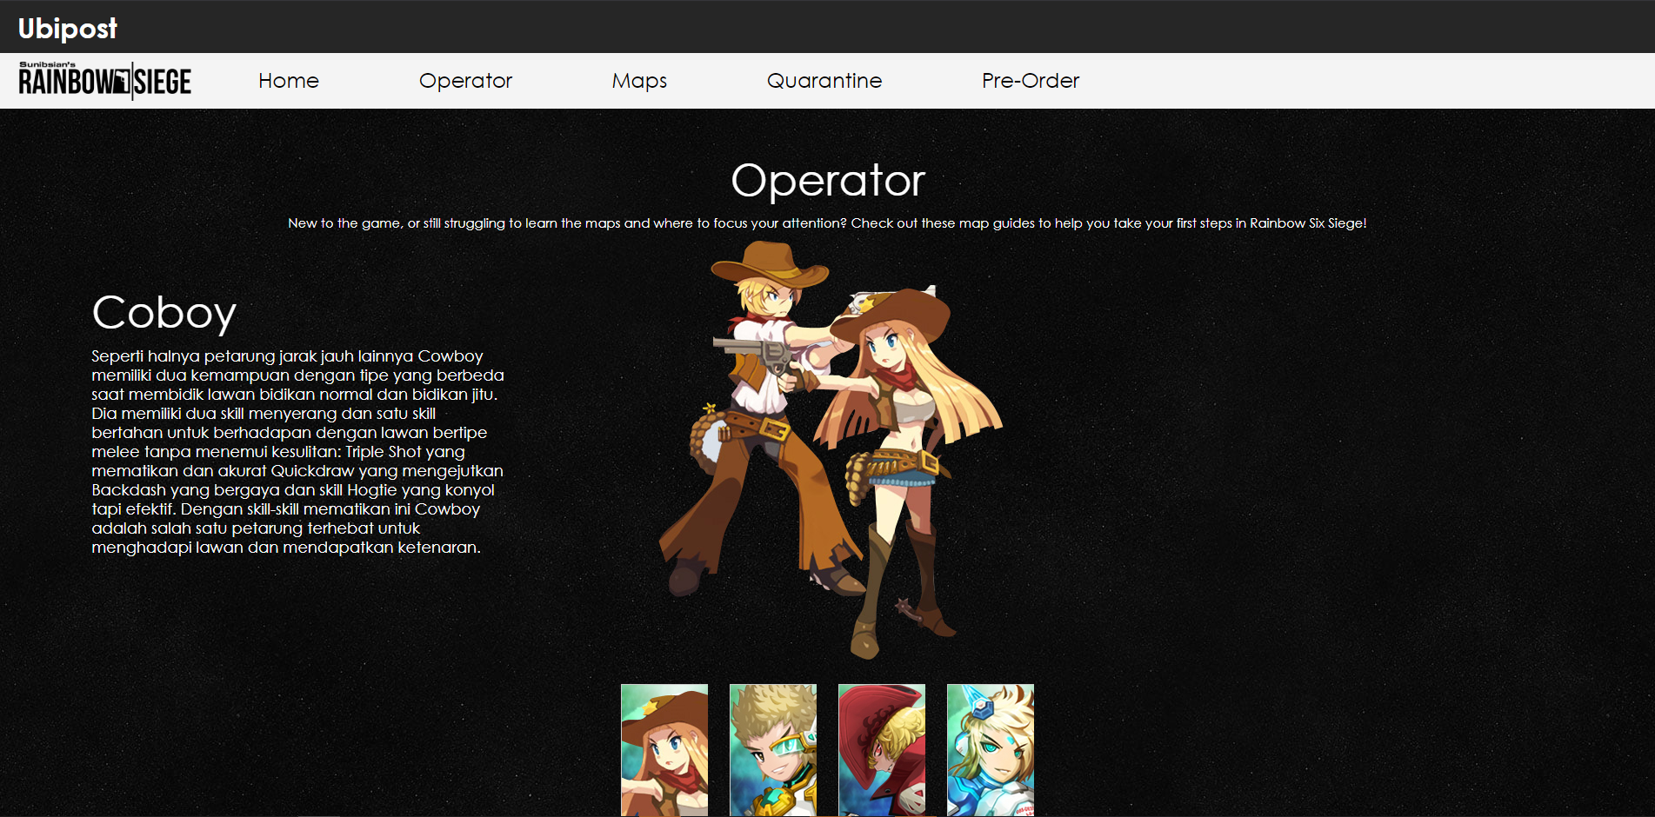

operator page pada saat 800px :

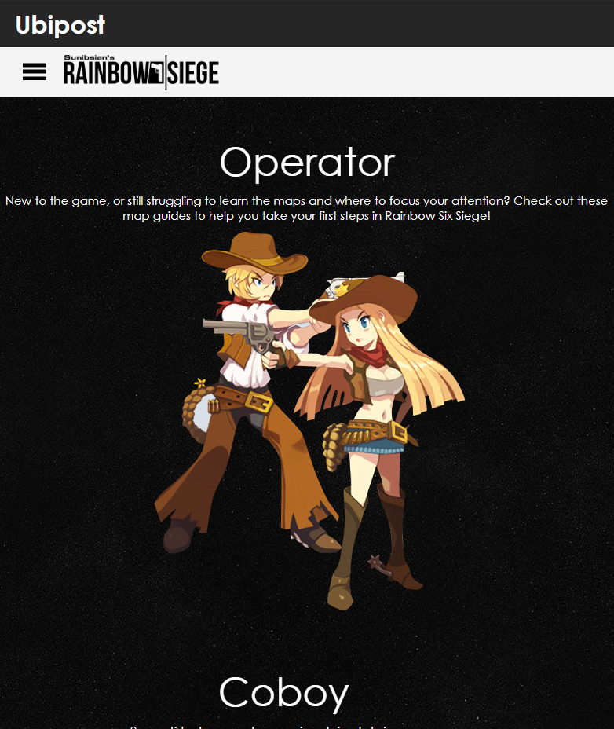

**Maps Page :**

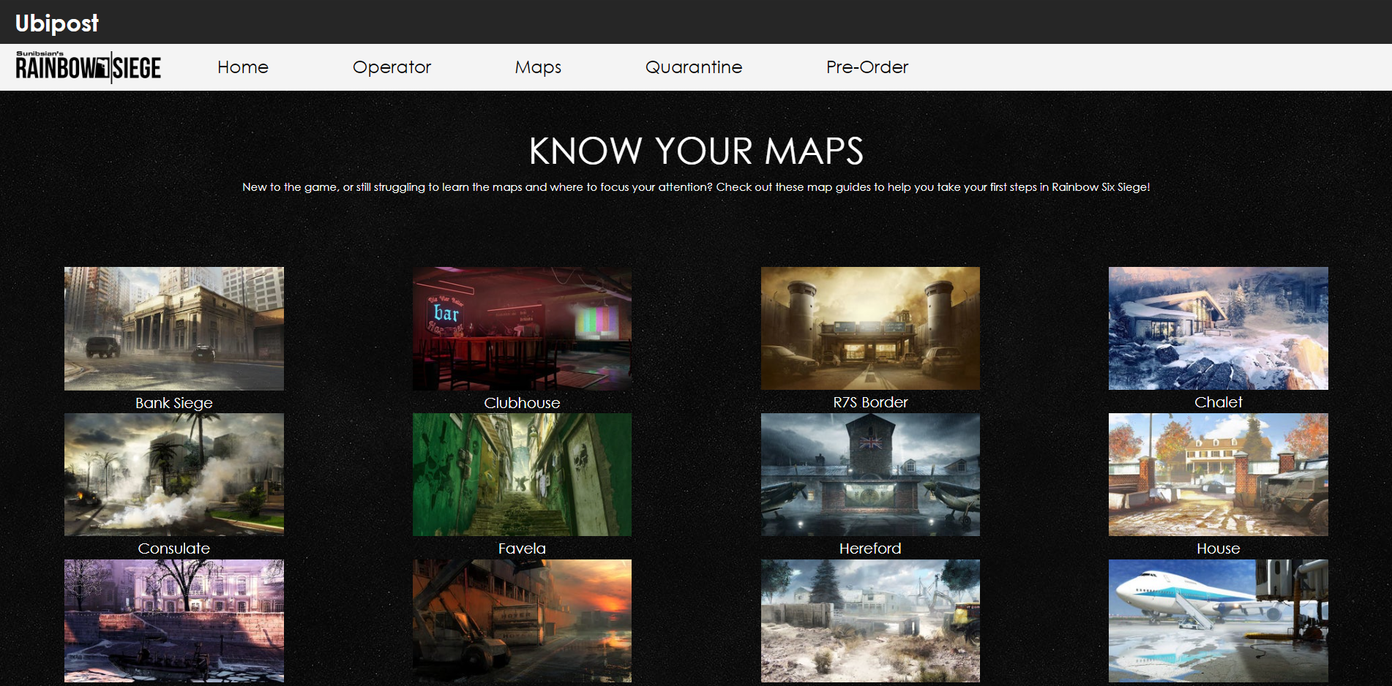

Maps page pada saat 800px :

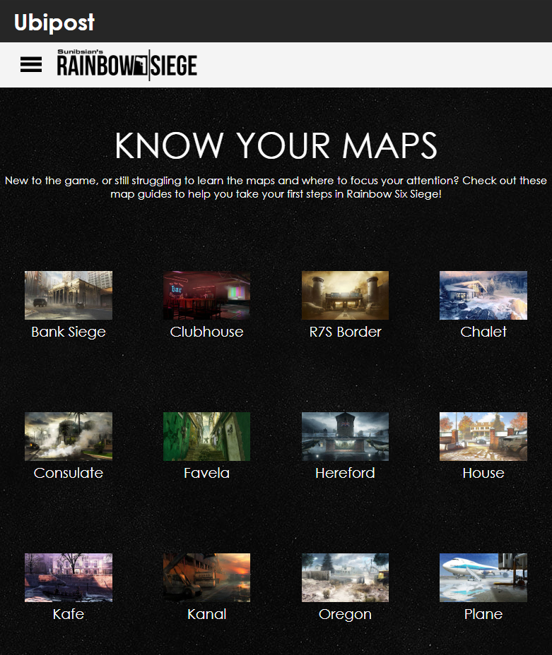

**Quarantine Page :**

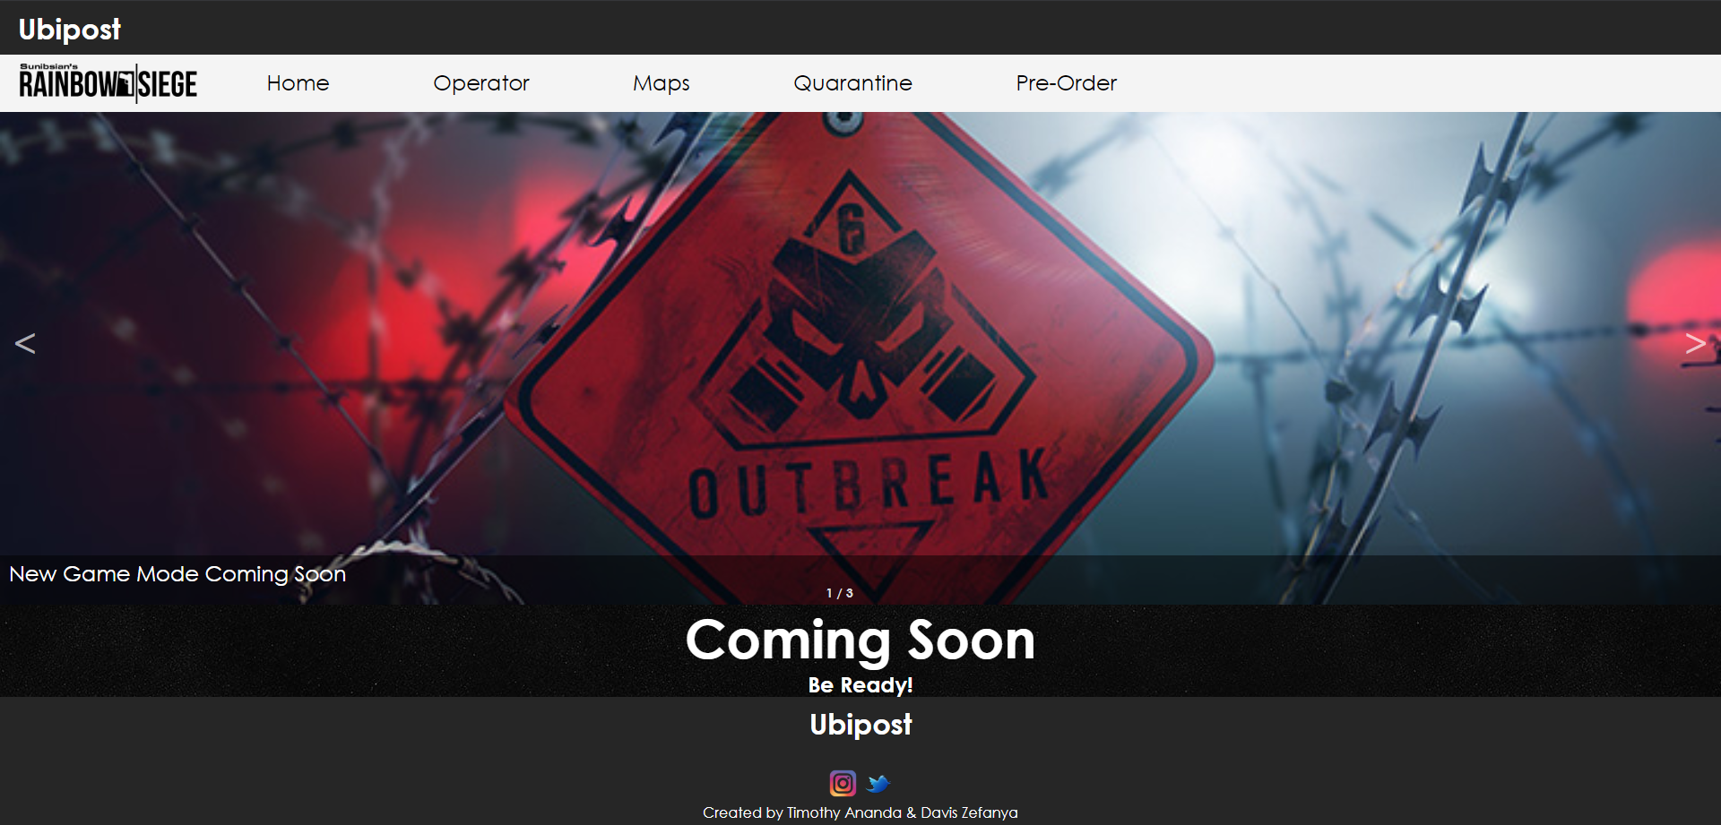

Quarantine page pada saat 800px:

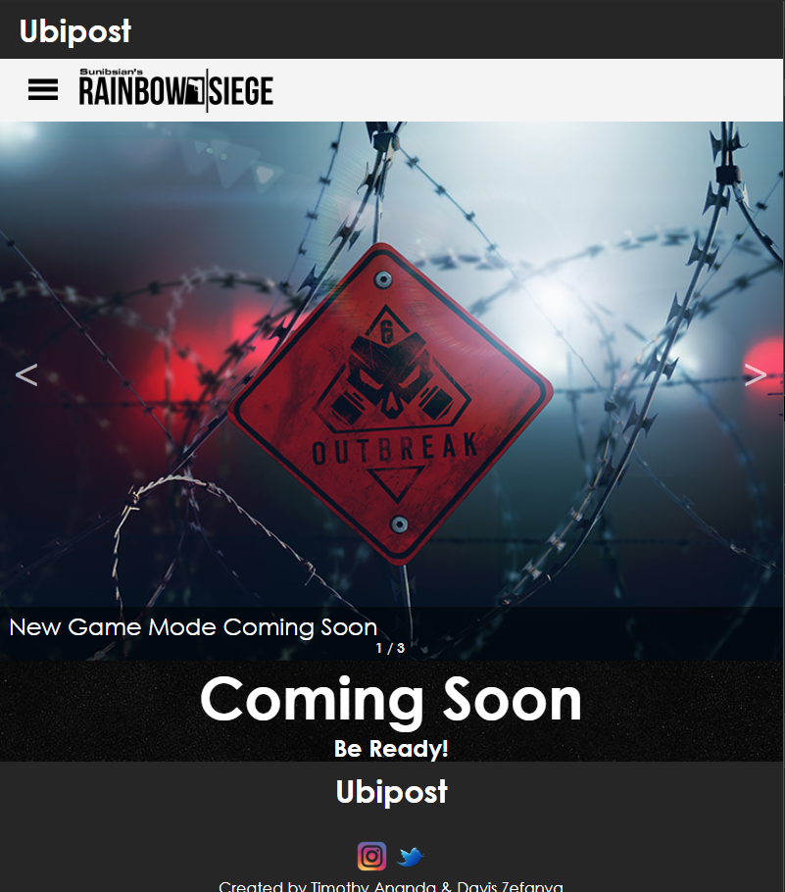

**Pre-Order Page :**

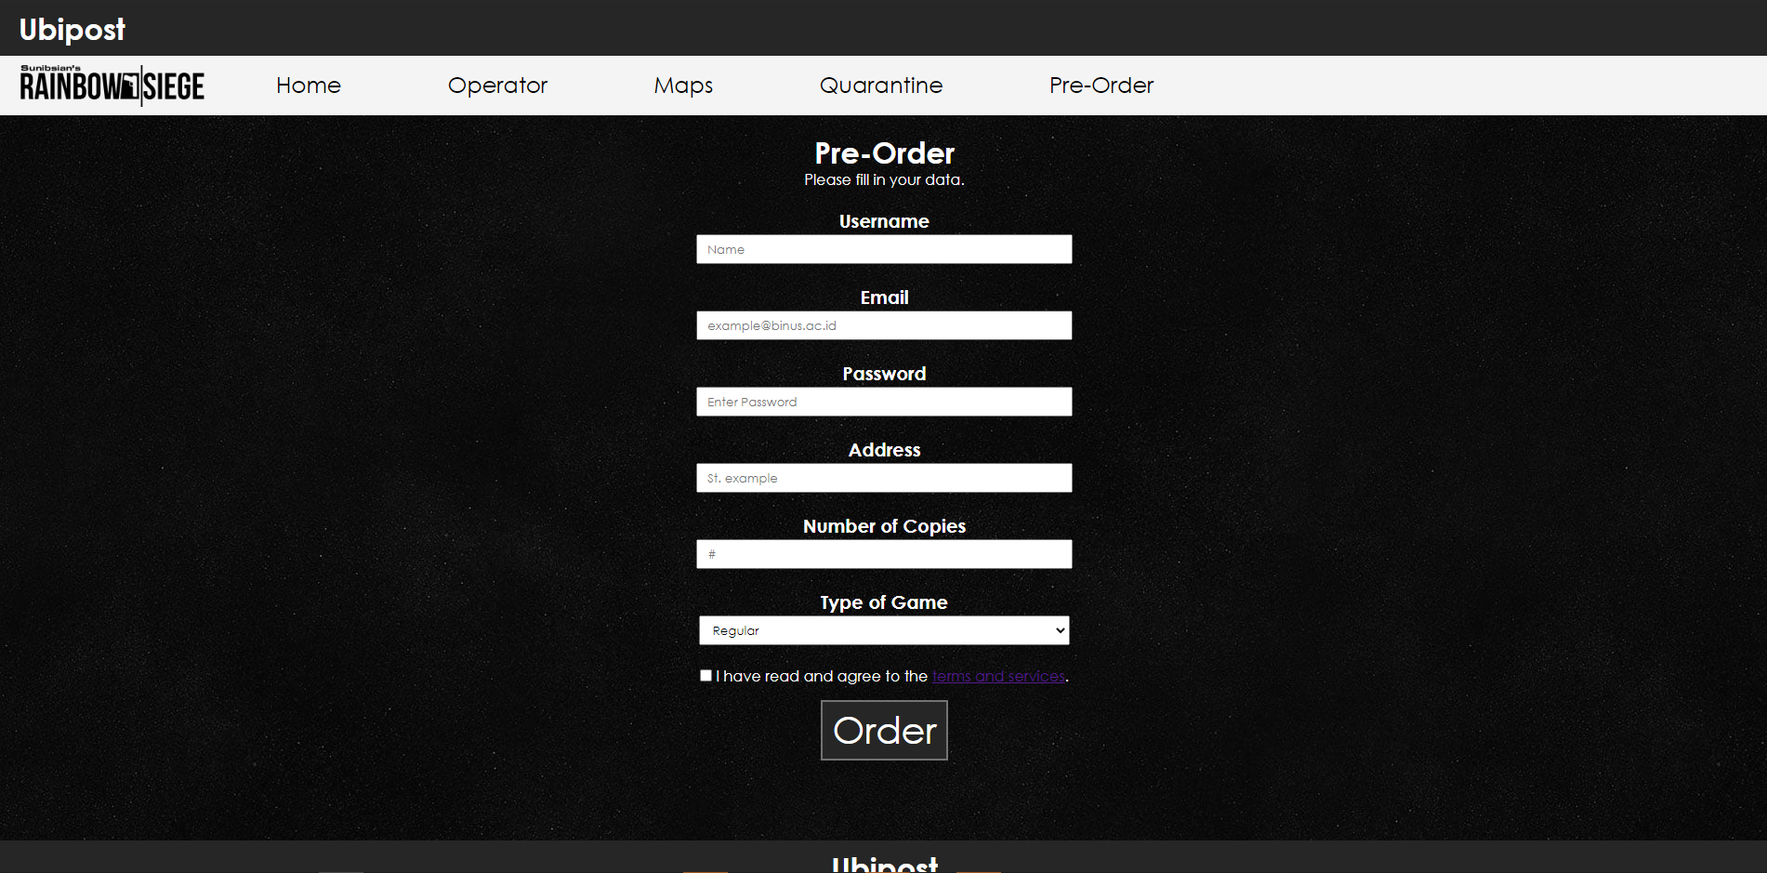

Pre-Order Page saat 800px :

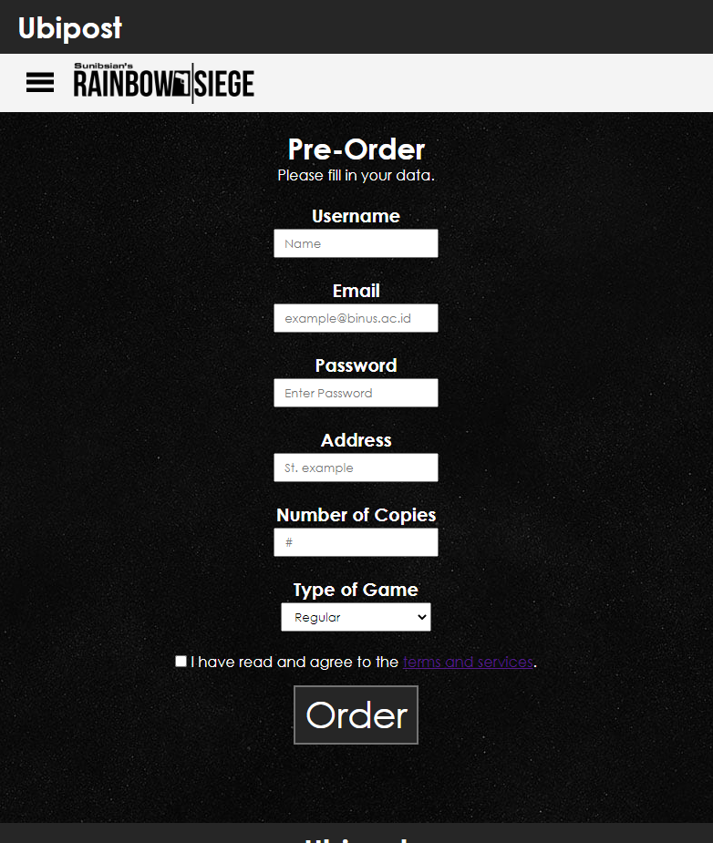

Refrence :

* <https://lostsaga.gemscool.com/heroes/category/3#>;
* <https://www.pointblank.id/>
* https://www.ubisoft.com/en-us/game/rainbow-six/siege
* <https://www.ign.com/wikis/rainbow-six-siege/Maps>
* <https://rainbowsix.fandom.com/wiki/Outbreak>
* <https://www.google.com/imgres?imgurl=https%3A%2F%2Fwww.windowscentral.com%2Fsites%2Fwpcentral.com%2Ffiles%2Fstyles%2Flarge%2Fpublic%2Ffield%2Fimage%2F2020%2F04%2Frainbow-six-quarantine-ela.jpg%3Fitok%3DGQdoa3Un&imgrefurl=https%3A%2F%2Fwww.windowscentral.com%2Frainbow-six-quarantine&tbnid=ddZWZ7k42_1AdM&vet=12ahUKEwiEs4Hj-uTpAhUAnEsFHcCYCGMQMygAegUIARDLAQ..i&docid=XuAplA4yrb_V-M&w=800&h=450&q=quarantine%20mode%20r6&safe=strict&ved=2ahUKEwiEs4Hj-uTpAhUAnEsFHcCYCGMQMygAegUIARDLAQ>